Support Vector Machine - Evaluation
Generated: 2026-05-26 13:15:14

Model Summary
Index | Metric | Value
0 | Algorithm | Support Vector Machine
1 | Kernel | rbf
2 | Training Samples | 80
3 | Test Samples | 20
4 | Features | 8
5 | Target Classes | 0, 1
6 | Support Vectors | 65
7 | Support Vector Percentage | 81.2%

Support Vector Summary
Index | Class | Support Vectors per Class
0 | 0 | 39
1 | 1 | 26

Summary Metrics
Index | Metric | Value
0 | Accuracy | 0.6
1 | Balanced Accuracy | 0.5
2 | Macro Precision | 0.3
3 | Macro Recall | 0.5
4 | Macro F1 Score | 0.375
5 | Test Samples | 20.0

Confusion Matrix
Index | Pred_0 | Pred_1
Actual_0 | 12 | 0
Actual_1 | 8 | 0

Confusion Matrix Details
Index | True Negatives | False Positives | False Negatives | True Positives | Accuracy | Balanced Accuracy | Precision (Macro) | Recall (Macro) | F1 Score (Macro)
0 | 12.0 | 0.0 | 8.0 | 0.0 | 0.6 | 0.5 | 0.3 | 0.5 | 0.375

Classification Report
Index | precision | recall | f1-score | support
0 | 0.6 | 1.0 | 0.75 | 12.0
1 | 0.0 | 0.0 | 0.0 | 8.0
accuracy | 0.6 | 0.6 | 0.6 | 0.6
macro avg | 0.3 | 0.5 | 0.375 | 20.0
weighted avg | 0.36 | 0.6 | 0.45 | 20.0

ROC Curve Points
Index | False Positive Rate | True Positive Rate
0 | 0.0 | 0.0
1 | 0.08333333333333333 | 0.0
2 | 0.08333333333333333 | 0.125
3 | 0.4166666666666667 | 0.125
4 | 0.4166666666666667 | 0.25
5 | 0.8333333333333334 | 0.25
6 | 0.8333333333333334 | 0.75
7 | 0.9166666666666666 | 0.75
8 | 0.9166666666666666 | 0.875
9 | 1.0 | 0.875
10 | 1.0 | 1.0

AUC
Index | AUC
0 | 0.28125

Test Set Predictions
Index | Index | Actual | Predicted
0 | 83 | 1 | 0
1 | 53 | 0 | 0
2 | 70 | 1 | 0
3 | 45 | 0 | 0
4 | 44 | 0 | 0
5 | 39 | 0 | 0
6 | 22 | 1 | 0
7 | 80 | 1 | 0
8 | 10 | 0 | 0
9 | 0 | 0 | 0
10 | 18 | 0 | 0
11 | 30 | 0 | 0
12 | 73 | 1 | 0
13 | 33 | 0 | 0
14 | 90 | 0 | 0
15 | 4 | 1 | 0
16 | 76 | 1 | 0
17 | 77 | 0 | 0
18 | 12 | 0 | 0
19 | 31 | 1 | 0

Visualizations
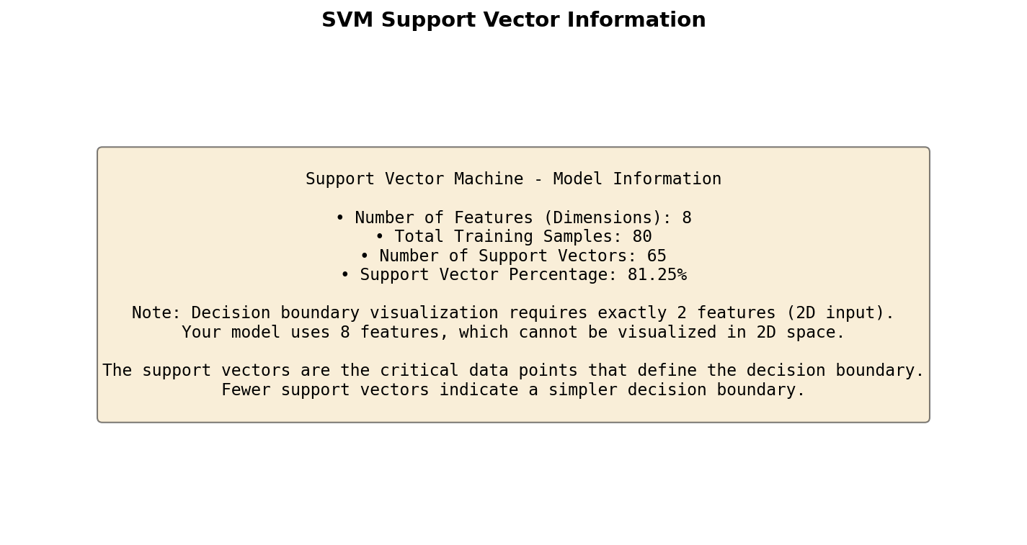
Figure 1

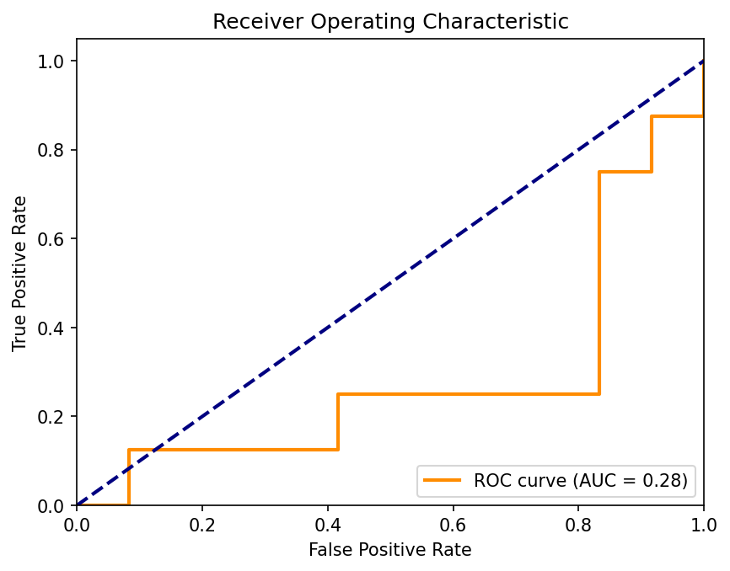
Figure 2

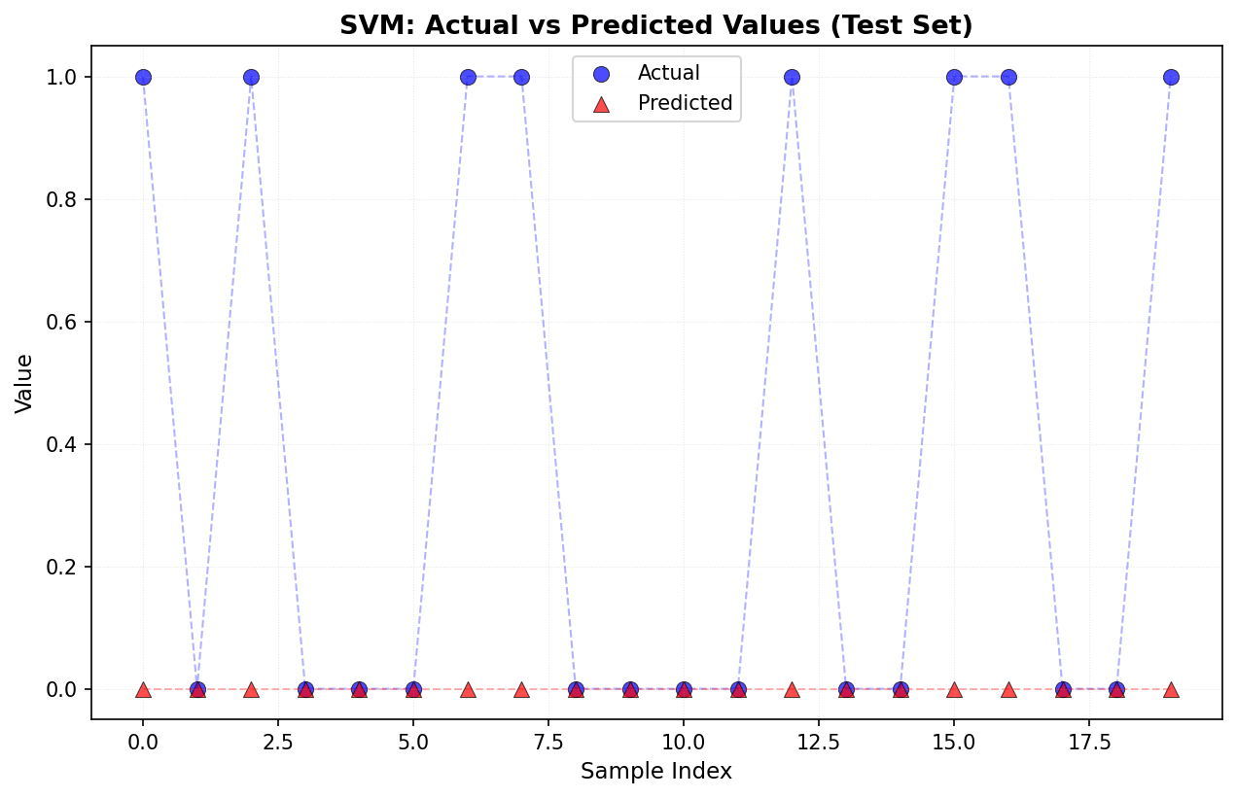
Figure 3

